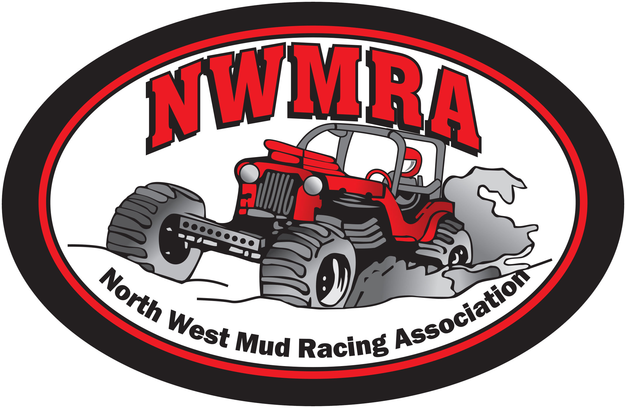
North West Mud Racing Association

46229 Yale Road PO BOX Chilliwack, B.C V2P6J1

Become a Sponsor

On behalf of the North West Mud Racing Association, I would like to thank you for taking the time to read and consider our sponsorship proposal for this coming race season. We are thrilled to be returning for another season of racing. Last year thousands of people enjoyed our 4X4 mud racing events at various tracks throughout B.C. Our club is a well established figure in the community and has been around for over 30 years.

Each year our non-profit association strives to bring world class competitive mud racing to British Columbia in a safe and family friendly environment. Our sanctioned races allow for 12 different classes of racing, from the exciting Blown Alcohol Paddle class down to our Street Stock class which allows anyone to race their stock 4X4s for fun and trophies! We also have the ever-exciting Blow Alcohol Mega Trucks racing in the Hill n Hole class where trucks fly through the air and land in a pit of mud! NWMRA also has a junior racing class, kids can now have fun and compete in two different classes!

Below is a list of our sponsorship options available; we have a variety of sponsorship opportunities to suit every size business.

Your sponsorship helps with the success of our non-profit association; we look forward to partnering with businesses such as yours. Our racing is all done in the summer months but we work year round to make sure every race season is successful. You can also find us on Facebook at Northwest Mud Racing Association.

Please feel free to contact us via email at contact@nwmra.com should you have any questions. The NWMRA and members thank you in advance for your support.

Contact us by email or phone:

Promotions Committee:  contact@nwmra.com  Etransfers to:  treasurer@nwmra.com | NWMRA President  Leanna Davies  604-374-1515 | Vice President  Gavin McDonald  604-618-6925 | Vice President  Michael Van Der Meij  604-613-0049

NWMRA Sponsorship Packages

The North West Mud Racing Association is looking to partner with local businesses and offer them a unique marketing opportunity. We typically have 5 races per year with attendance ranging from 1500 to over 5000 people at each race. We have different sponsorship options available:

- Spectator Prize Give Away

  - Donate items for us to give away to the spectators
  - Donations such as hats, t-shirts, gift certificates, toys, auto accessories, coupons to your business and other merchandise or services are a hit with our spectators.
  - Your company’s name will be announced as the donator of the prize item as it is given away, and we will recognize your business as a prize sponsor repeatedly during the race weekend.

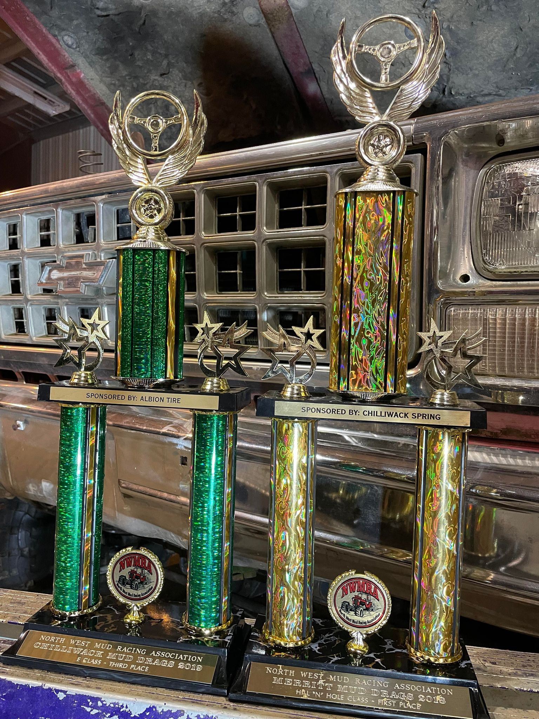
- Trophy Class Sponsorship- sponsor a class for one race weekend $150 to $250

  - Your company name will be engraved on 3 trophies (1st, 2nd and 3rd) for one race weekend.
  - Your company name will be announced repeatedly over the PA during the race weekend.
  - Facebook exposure

- Trophy Series Sponsorship- sponsor a class for an entire race season $800
  - Your company name will then be engraved on 3 trophies (1st, 2nd and 3rd) per race
  - Your company name will be announced repeatedly over the PA during race weekends
  - Your logo on a banner at all races (Payment must be received before May 25th, to allow time for banner to be made)
  - Website and Facebook exposure

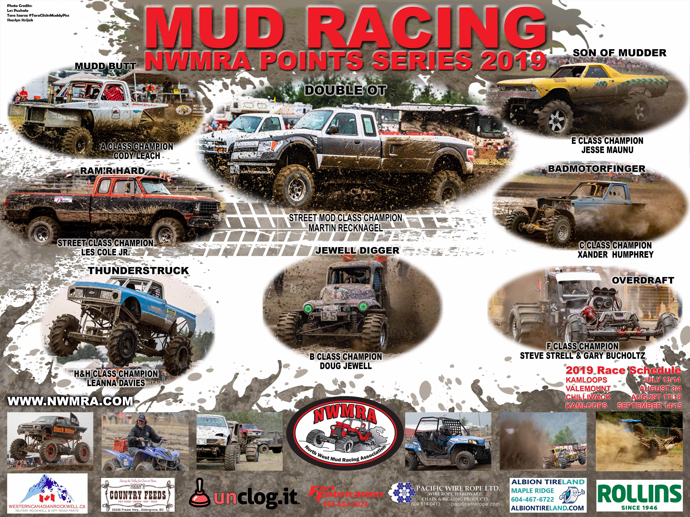
- Poster Sponsorship $500

  - Your company logo and information will be displayed on our posters
  - Posters are given out at every race to the audience and kids
  - Posters are handed out and put on display at local businesses and around the community

Want to do more?

Gold Sponsor $400 to $999
- Acknowledgment at all Races
- Your logo on a banner at all races (Payment must be received before May 25th, to allow time for banner to be made)
- Website and Facebook exposure

Platinum Sponsor $1000 to $1500

- Acknowledgment at all Races
- Your logo on a banner at all races (Payment must be received before May 25th, to allow time for banner to be made)
- Website and Facebook exposure

See attached sponsorship list. Gold and Platinum sponsorship money will help with items under Others ways to Help and Track Supply Donations Needed.

Titanium Sponsor- (Large Corporate sponsorship) Dollar value to be discussed with the Board of Directors. $2000 and greater.

Options include:
- Trophy Points Series named after your company or media sponsorship for a radio campaign
- Acknowledgment at races
- Your logo on a banner at all races (Payment must be received before May 25th, to allow time for banner to be made)
- Website and Facebook exposure

Contact us by email or phone:

Promotions Committee:  contact@nwmra.com  Etransfers to:  treasurer@nwmra.com | NWMRA President  Leanna Davies  604-374-1515 | Vice President  Gavin McDonald  604-618-6925 | Vice President  Michael Van Der Meij  604-613-0049

